Year 12 Acid and Bases Questions 3

Question 1

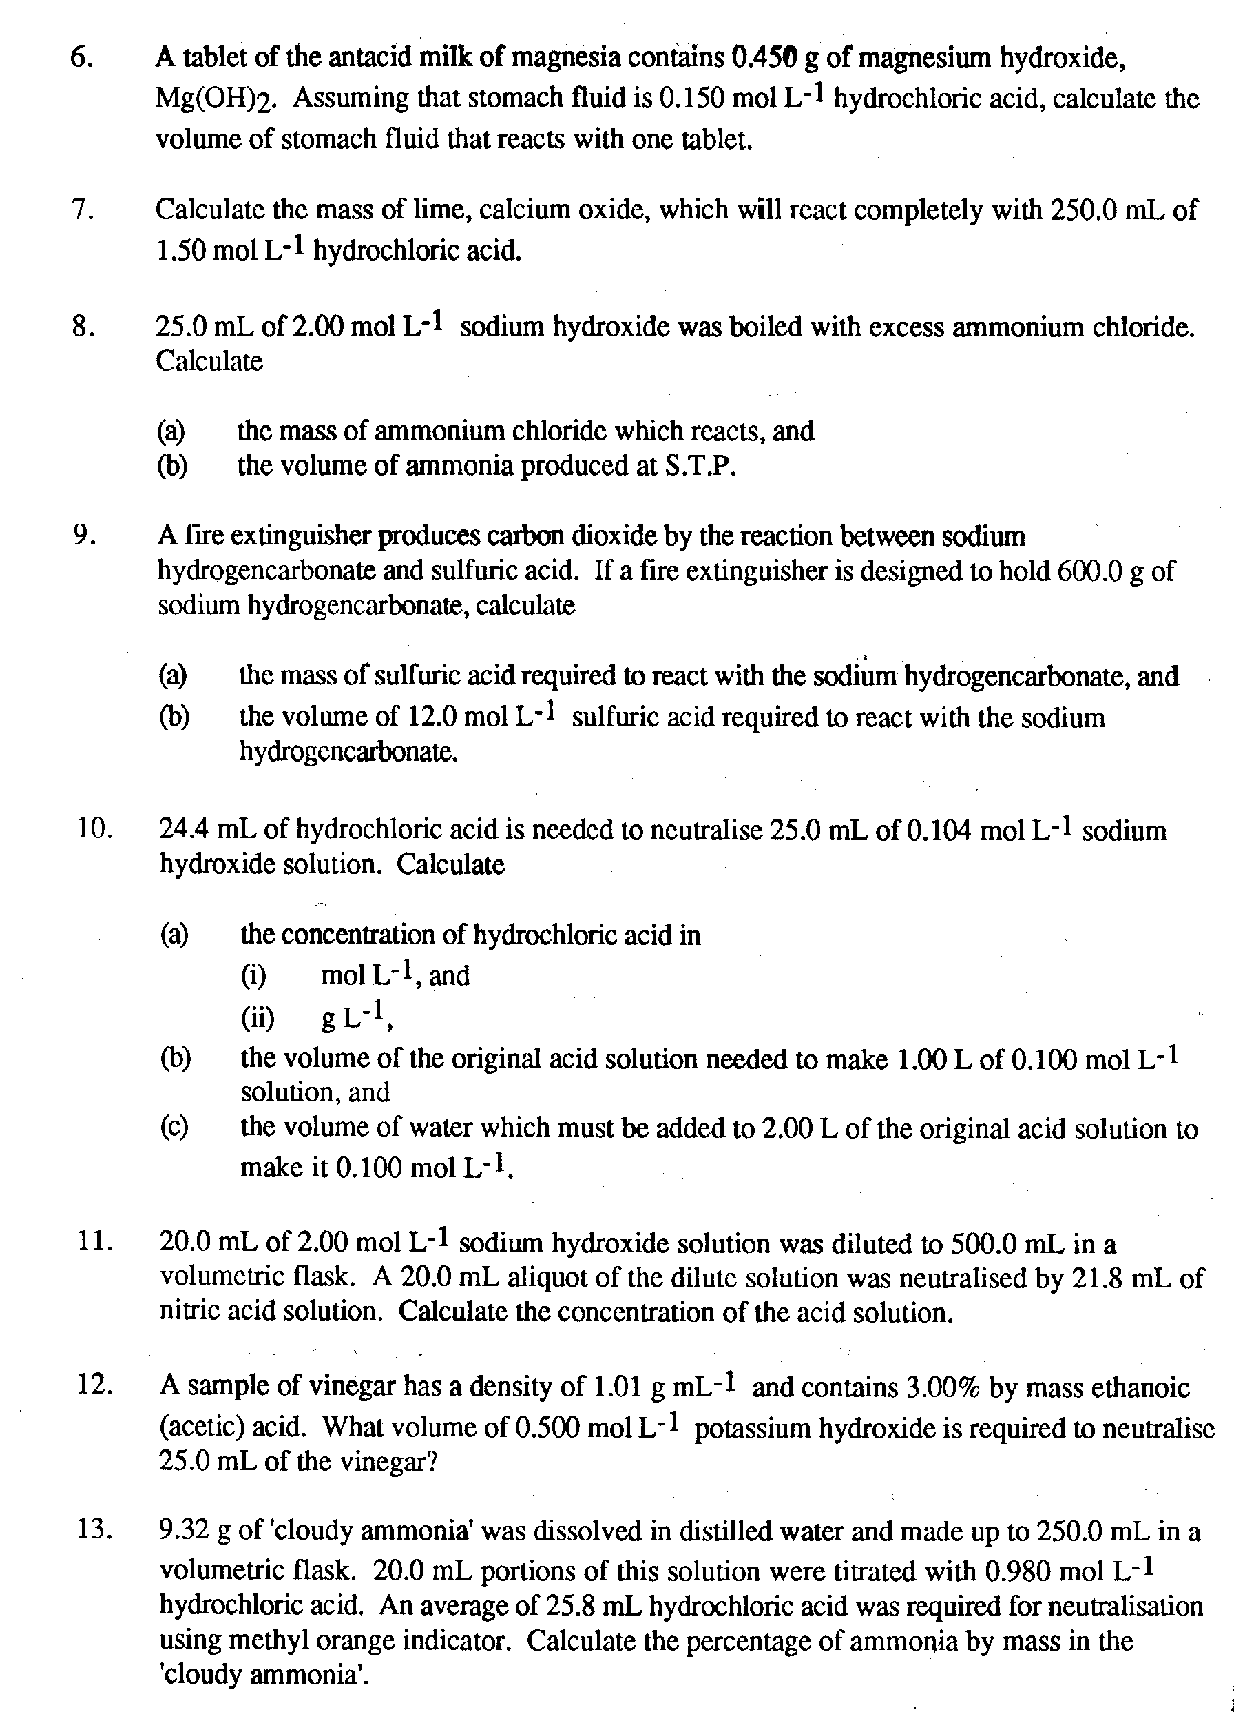
(4 marks)

Question 2

(6 marks)

Question 3

(6 marks)

Question 4

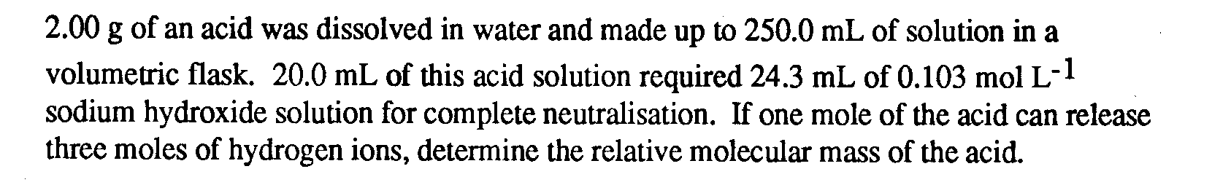
(6 marks)

_____________________________________________________________________

_____________________________________________________________________

_____________________________________________________________________

_____________________________________________________________________

_____________________________________________________________________

_____________________________________________________________________

_____________________________________________________________________

_____________________________________________________________________

_____________________________________________________________________

_____________________________________________________________________

_____________________________________________________________________

_____________________________________________________________________

_____________________________________________________________________

_____________________________________________________________________

